A1336 AM,S-Peru-Chancay-Doll-Embroidered Face-Hammock-1940 CE

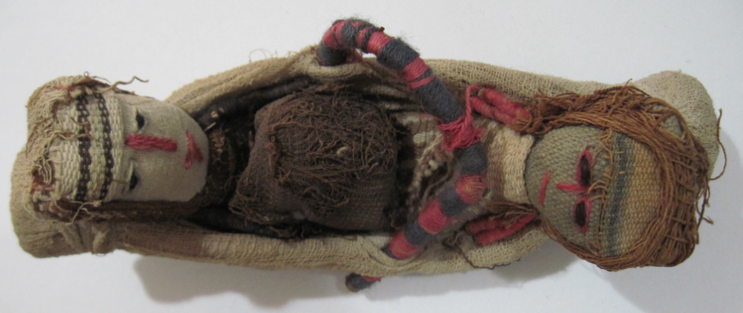

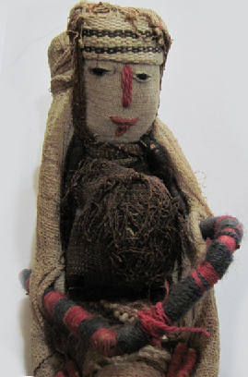 

**Case no.: 7**

**Accession Number: 1336**

**Formal Label:** Peru-Chancay-Doll-Embroidered Face-Hammock-1940 AD/CE

**Display Description:**

The Chancay culture developed 1000-1470 AD/CE on the central coast of Peru between the valleys of Fortaleza, Pativilca, Supe, Huaura, Chancay, Chillón, Rimac and Lurin after the demise of the Wari empire.

These beautiful dolls, dressed in exquisite textiles, blur the lines between past and present. These dolls were sewn sometime in the 1940’s-1950’s with fragments of cloth dating to 1000-1470 AD/CE.

In the Chancay culture, these dolls were placed in graves, and it is believed that they were meant as cheerful, guardian companions for the departing soul. They are always women, often in hammocks such as this pair. These dolls offer us a rare chance to closely examine the exquisite threads and fabrics from one of the world's most sophisticated textile cultures.

Dolls like these are replicas of a doll-making tradition that existed in the Chancay culture and can be distinguished from original Chancay dolls that have special tapestry woven faces that are unique to each doll. The replicas, each still unique, have embroidered faces like these.

**LC Classification:** F 3429.1 .C47

**Date or Time Horizon:** 1940’s-1950’s

**Geographical Area:** Lima

**Map, GPS coordinates: 11º34'6.61" S 77º14'13.9" W**

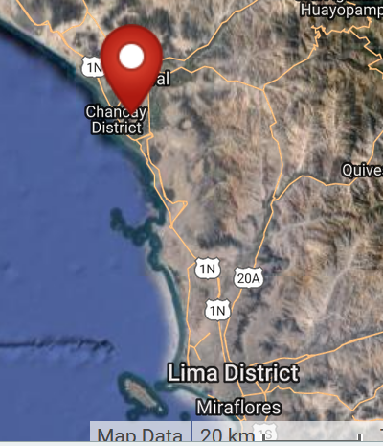

**Cultural Affiliation:** Chancay

**Media:** wool, vegetable dyes

**Dimensions:** L 214.78 mm, 8.46 in; W 77.47 mm, 3.05 in

**Weight: 93 gm, 3.25 oz**

**Condition: sewn about 1940 from textiles dating to ca. 1100-1400 AD/CE**

**Provenance:** procured in Lima ca. 1960

**Discussion:**

Textile production was enormous in the dry air of the central coast of Peru, which is considered one of the driest places on earth. Lack of bacteria, and arid soil have combined to preserve the fabrics amazingly well.

**References:**

Hodnett, M. K. 1999. *Pre-Columbian dolls in the Amano Museum = Muñecos precolombinos en el Museo Amano*. Lima, Perú: Museo Amano.

Lehman, Hattie Jo. 2005. “Textiles of the Chimú and Chancay cultures of coastal Peru woven during the Late Intermediate Period: a comparison of processes and techniques.” M.A. University of Montana.